KDM LAB Assignment -2

As part of the KDM Lab assignment -2, I made a app that displays the total number of states when a country code is entered and searched.

The app displays the total number of the states in a country according to the json data in yahoo geo planet api.

URL of the Yahoo geo planet API: http://developer.yahoo.com/geo/geoplanet/guide/api-reference.html#api-states

I have displayed first 5 states available in the json data of the website.

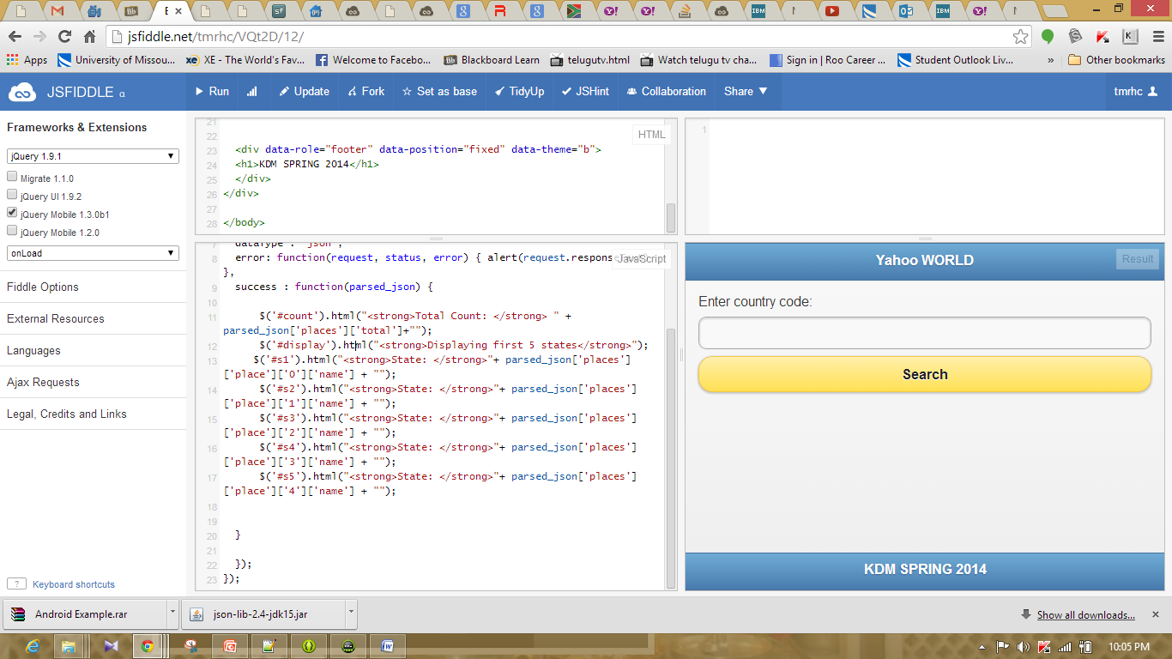

Above screenshot represents the main page of the site.

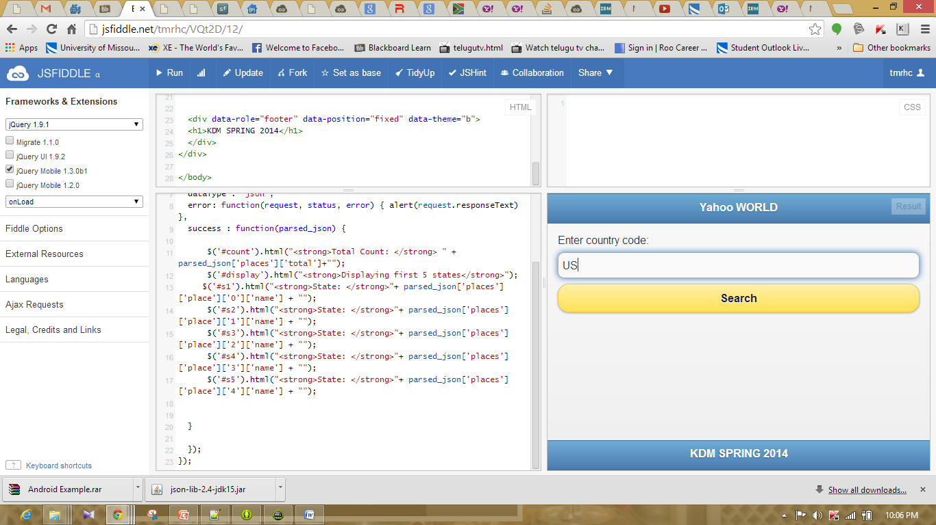

When the code of the country is entered and clicked on the search. Total number of states in the country will be displayed.

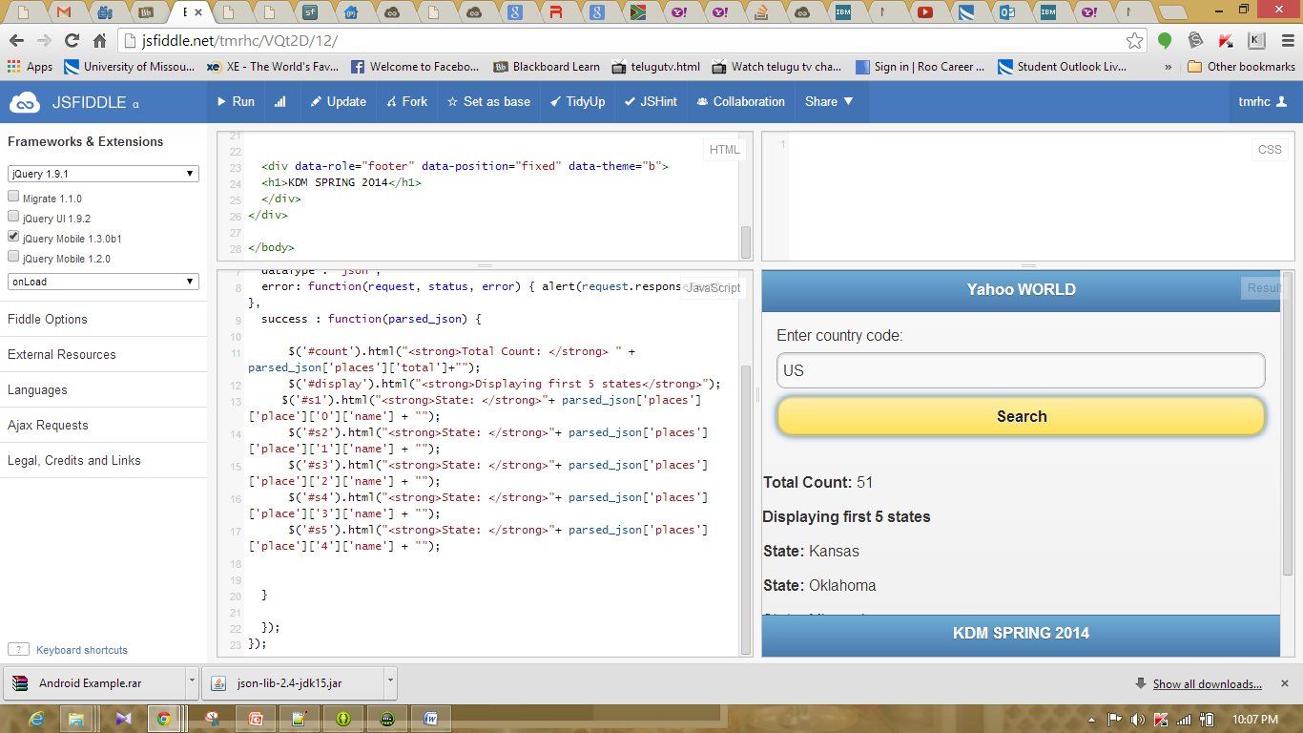

Below screenshot represents the first 5 states as per the json data of the website.

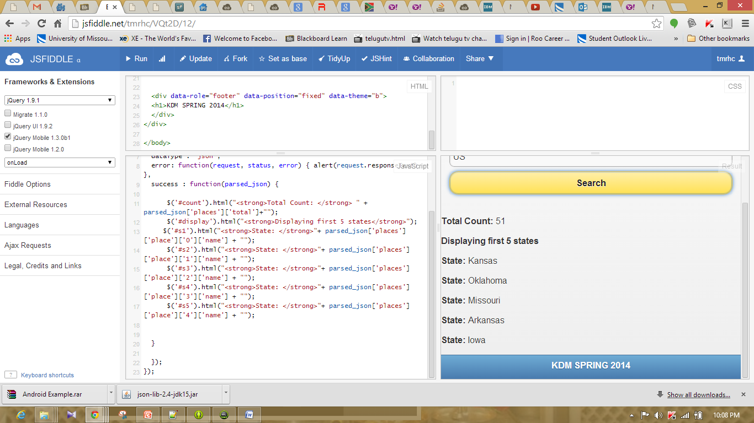

When incorrect country code is entered in the site then a javascript alert of invalid data will be retrieved to the user.

